Lee Satterwhite
ISOM 835
Loan Approval Analysis Report
For this project I analyzed a dataset from a financial organization about their clients and loan approval. The dataset includes over 32,000 clients with 12 features used to determine approval of the loans, such as the clients’ age, employment status, amount of the loan, and the loan as a percentage of the clients’ income. My objective was to identify which factors had the strongest correlation with the loan being approved and how that can be helpful information. I analyzed the data using Python code in Google Colab to develop several predictive models (a decision tree model, a random forest model, and a gradient boosting model) based on the data to search for correlations and to test the data to find accurate predictions. From my analysis, the gradient boosting model was best able to predict approvals using the data. I determined that three of the strongest factors for approval were the percentage of the loan in relation to income, the interest rate of the loan, and the income of the client. These factors would be most helpful for potential clients to understand when applying to be approved for their loans. My suggestion for the organization would be to make those points clear when going through the application process to help clients have a better idea if they will be approved or not. I would also suggest that the organization keep a close eye on those factors when looking at approving potential clients. One of the limitations of this report is that there are some factors that I was unable to include in my computed analysis, such as defaulting on previous loans, which have strong correlations to new loans being approved. Past behavior and actions are nearly always good predictors of future behavior.
To go into further detail, let’s first look at the dataset and discuss what it is and why we’re looking at it. (https://www.kaggle.com/datasets/laotse/credit-risk-dataset) The data was uploaded to Kaggle, which is a site dedicated to hosting data for people to use for projects such as this. This scenario presents a credit bureau’s factors for approving potential loans. These factors include clients’ age, annual income, home ownership, employment, the intent, amount, and interest rate of the loan itself, the loan as a percentage of income, and clients’ credit history and history of defaulting. The problem I wanted to work on was finding out which of those factors have the biggest influence on approval. This would be helpful information to the credit bureau as well as potential clients. Once the decisive factors are found, the business can show potential clients what they prioritize in approving their loans, which in turn helps clients make more informed decisions and allows them to know what adjustments or changes they might need to make if they’re able. This problem matters to the business because it would bring in more clients and give them a more focused direction on their approval method, and it would also create more informed clients in the process.
The overall objective of my project is to prepare the data, analyze it, develop several predictive models to test whether a loan application would be approved based on which factor or factors we determine to have the highest correlation to previously approved applications, and identify which model would be best used for future predictions. I chose to focus primarily on the numerical data to return a more measurable result rather than include qualitative data such as prior defaults or home ownership. This will admittedly result in our data being somewhat incomplete but for my purposes I wanted to work strictly with the numbers to keep the analysis simpler and more streamlined. I will address the non-numerical variables and their importance later in this report as they are also useful, but they did not fit into the analysis I wanted to carry out.
First, let’s look at the data itself. In order to prepare the data, I imported it into Google Colab and loaded the necessary Python libraries, primarily pandas, numpy, matplotlib, and scikit-learn. I also filtered out any null values so they would not skew the data. The following graphs and charts are some initial bar charts to show distribution across the numerical/binary variables in the dataset, as well as some tests for correlation between variables. From these we can get some ideas on what we might want to investigate for further analysis. From the charts, we can see that most applicants are below 50, on average the loans are below $10,000, the interest rates of the loans largely fall between 10 and 15%, and most of the loans would represent less than 20% of the applicants’ incomes.
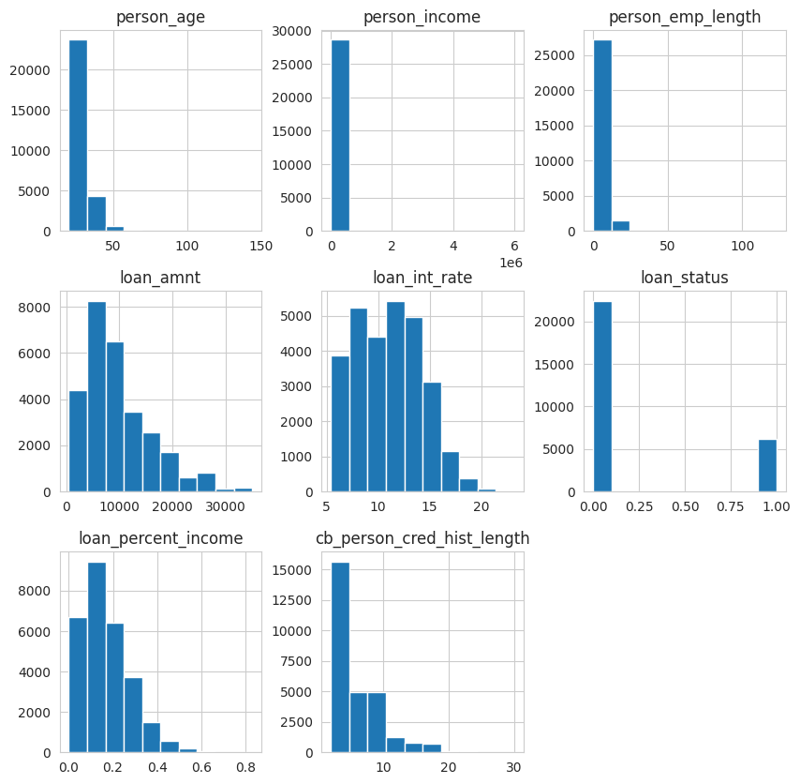
From here, I chose to look at potential correlations between the amount of the loan compared to its approval, as well the distribution of loans approved compared to applicants’ incomes. The box chart shows that more loans were approved for lower amounts, while there were more applications for higher amounts that were not approved, which I found interesting. The next chart shows approval of loans compared to income of the applicant, and a hypothesis could be made that the higher an applicant’s income the more likely the loan would be approved, as they would likely be more readily able to pay it back. I next included a correlation heatmap to check for potential correlations between the numerical factors of the application. From this chart, we can see that there are surprisingly low correlations across most of the variables, but there are two likely correlations that can be drawn from this; an applicant’s age is likely to have a high correlation to their credit history, as in the older they are the more likely their credit would be a deciding factor, and interestingly, the amount of the loan in relation to the applicant’s income could have a fair correlation, meaning that the higher percentage the loan represents in relation to their income, the more that could be a factor in its approval.
Fortunately, in this phase, I didn’t run into many quality control issues with the data. I chose which factors and variables I wanted to investigate further and isolated those for my testing dataframes. The object data columns, as previously mentioned, were excluded from the purposes of this analysis.
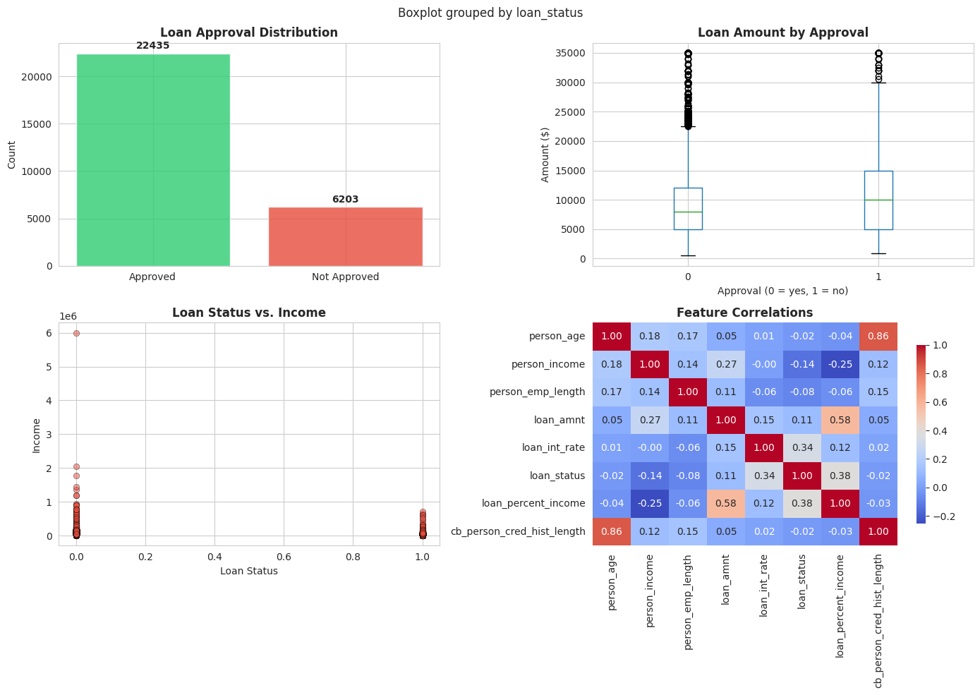
After this initial exploratory analysis, I took the data and split it into train-and-test sets to run through the predictive models I would then make. I split the data along the “loan status” column to check the other variables against approval. Then I created three different models to run the train-and-test data through; a Decision Tree model, a Random Forest model, and a Gradient Boosting model. I will explain the differences between these models after we see the results.
Next let's look at our results from building our predictive models and what those results can tell us about the data, as well as our feature importance for loan approval. Here are some bar charts to show prediction performance and the confusion matrix of the most effective model to show its accuracy.
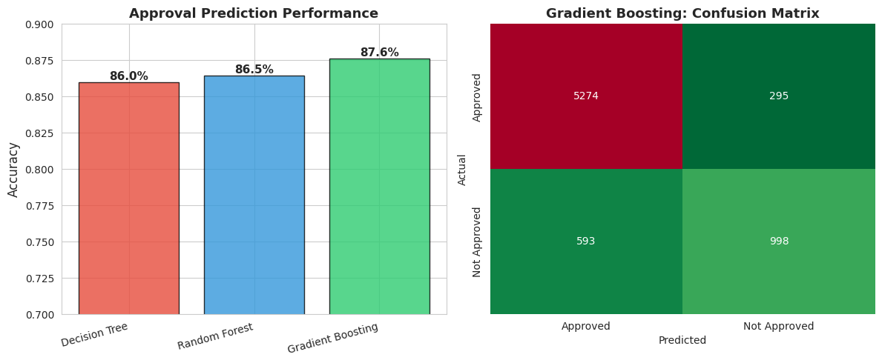
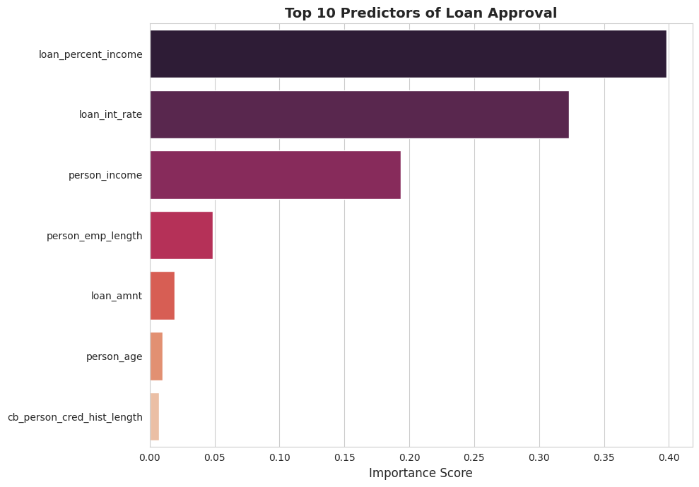
We can see from the first bar graph that the Gradient Boosting model gives us the highest predictive accuracy. This makes sense to me as Gradient Boosting models create an initial model using the train-test sample data and then creates another based on the results of the previous model, iterating each time and adjusting to optimize the results. For comparison, Decision Tree models create many individual decision trees one at a time changing the order of importance of the variables each time until it arrives at a result and until it has exhausted all permutations, while Random Forest models create many decision trees and randomize the order of importance of the variables each time. Gradient Boosting in this case finds the optimal sequence of variables in the decision tree by learning from the previous trees and adjusting the variables until it finds the best result.
The confusion matrix shows more detail of the model’s accuracy as well. It was able to correctly predict over 5000 approvals and resulted in only a few hundred false positives or negatives. The cost of a false positive (a loan that the model says would be approved when it would not) in this case would be a loan that may not be repaid on time or may otherwise present a risk to the business, so those would be important to catch. Likewise, the cost of a false negative (a loan that would not be approved but statistically should) would be the loss of a potential long-term client, who would then lose out on their own opportunities if the loan had been approved.
Based on our results of feature importance, the strongest predicting factors of loan approval are the loan as a percentage of income, the interest rate of the loans, and the income of the applicant. Using this information, I would recommend decision-makers take those as key factors into consideration in their processes. As for other recommendations, I would suggest that the business let clients know which variables they consider most important when making their decisions so clients can be more informed. If the business wishes to make some adjustments to their upper or lower limits on what they would approve to bring in more clients and provide more loans, they can also take these factors into account and think about what ranges would be acceptable to change.
From an ethical perspective, there is likely to be a certain amount of sensitive information in these applications, but for the purposes of this analysis none appears to be significant. Still, for privacy purposes, I will delete the data once the analysis is complete and the report has been turned in. I don’t believe there would be many biases in the data, at least in the manner I used it. For instance, if I had included home ownership in the dataset, that could have created a bias towards those applicants who rent or otherwise don’t own their homes. Another bias could have been created depending on the intended purposes of the loans, such as for education or medical purposes as opposed to personal investment or business concerns. Those factors are also very important to consider. I will work on practicing more ways to adapt and change the data to make sure those variables are included in future tests. Also, despite the data showing that they are not as significant factors as others, on the human interaction level there could also be biases against clients based on their age or credit history. Someone who is older is more likely to have a more stable credit history than a younger person, but a person with a poor credit history could also have other factors outside of their control that led to that situation.
In conclusion, I will once again address the limitations of this model regarding its accuracy. As mentioned above, I have excluded some qualitative variables in my models such as the intention of the loan and home ownership. These factors should not be discounted in future decision-making. The intended purpose of a loan could have a strong correlation to how much the application is for. Likewise, loans with similar purposes could have different sums, which could also influence how likely it is to be repaid. Home ownership, while not a guarantee, could also have a correlation with loans being repaid as they have a relative implication of stability and security. Another factor I did not include was prior defaults on loans. This is a very important variable to consider as past behavior and actions are, at least in a psychological perspective, strong indicators of future behavior. For future analysis, I would suggest finding ways to translate these qualitative variables into more quantitative datapoints to include them as well. This is something I intend to work on learning and practicing in future projects on my own. However, those limitations aside, I was able to carry out a successful analysis of certain numerical data, train and test several predictive models from that data, determined which model would provide the most accurate results, and identify the ten most important features within the data.

References
- Dataset: https://www.kaggle.com/datasets/laotse/credit-risk-dataset
- Code references and tutorials: Hasan Arslan/ISOM 835 lectures
- Python Libraries: pandas, numpy, matplotlib, plotly, seaborn, scikit-learn, warnings

